Base Diameter of a Cylinder
# Source: AI Source: Provided by: [Data Path: Persons Table -> ID Column: 1, Name_En Column: Motasem Essam] -> From: [ChatGPT] on [7/25/2026]
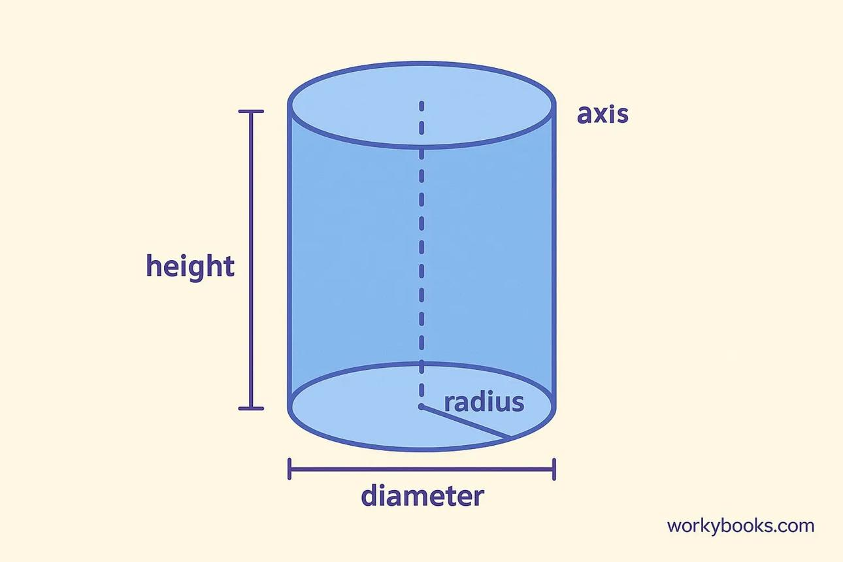

Definition
# Source: AI Source: Provided by: [Data Path: Persons Table -> ID Column: 1, Name_En Column: Motasem Essam] -> From: [ChatGPT] on [7/25/2026]
The base diameter of a cylinder is the length of a straight line segment that passes through the center of a circular base and connects two points on its circumference.
A cylinder has two circular bases. For a right circular cylinder, the bases are congruent, so their diameters are equal.
The base diameter is commonly represented by $D$ or $d$.

Simple Definition
# Source: AI Source: Provided by: [Data Path: Persons Table -> ID Column: 1, Name_En Column: Motasem Essam] -> From: [ChatGPT] on [7/25/2026]
The base diameter is the distance across a circular base through its center, from one edge to the opposite edge.

Geometric Representation
# Source: AI Source: Provided by: [Data Path: Persons Table -> ID Column: 1, Name_En Column: Motasem Essam] -> From: [ChatGPT] on [7/25/2026]
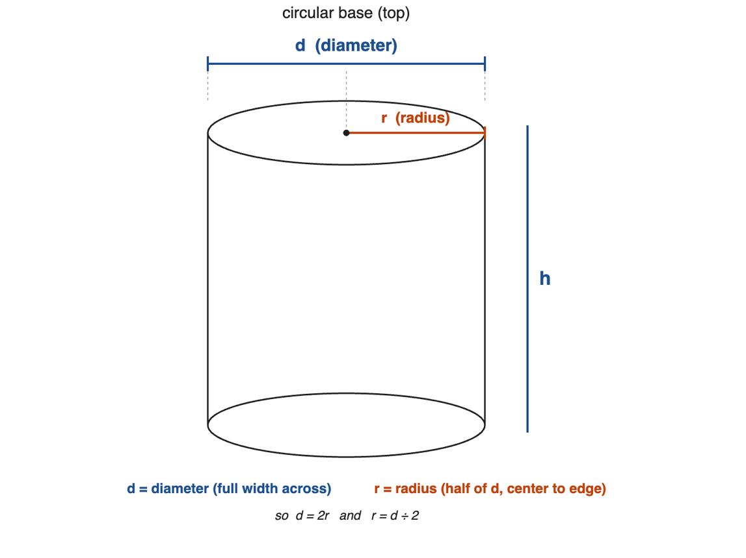
The base diameter is related to three important parts:
- Circular base: the circular face at the top or bottom of the cylinder.
- Center of the base: the center point of the circular face.
- Radius: the distance from the center to the circumference.
The diameter passes through the center and is twice the radius.
$$\boxed{D=2r}$$

Types of Base Diameter

Top Base Diameter
# Source: AI Source: Provided by: [Data Path: Persons Table -> ID Column: 1, Name_En Column: Motasem Essam] -> From: [ChatGPT] on [7/25/2026]
The diameter of the cylinder's top circular base.

Bottom Base Diameter
# Source: AI Source: Provided by: [Data Path: Persons Table -> ID Column: 1, Name_En Column: Motasem Essam] -> From: [ChatGPT] on [7/25/2026]
The diameter of the cylinder's bottom circular base.
For a standard cylinder with congruent circular bases:
$$\boxed{D_{\text{top}}=D_{\text{bottom}}}$$

Inner Base Diameter
# Source: AI Source: Provided by: [Data Path: Persons Table -> ID Column: 1, Name_En Column: Motasem Essam] -> From: [ChatGPT] on [7/25/2026]
For a hollow cylinder, the inner base diameter measures across the circular opening.
$$D_{i}=2r_{i}$$

Outer Base Diameter
# Source: AI Source: Provided by: [Data Path: Persons Table -> ID Column: 1, Name_En Column: Motasem Essam] -> From: [ChatGPT] on [7/25/2026]
For a hollow cylinder, the outer base diameter measures across the entire external circular boundary.
$$D_{o}=2R$$

Mathematical Formulas
# Source: AI Source: Provided by: [Data Path: Persons Table -> ID Column: 1, Name_En Column: Motasem Essam] -> From: [ChatGPT] on [7/25/2026]
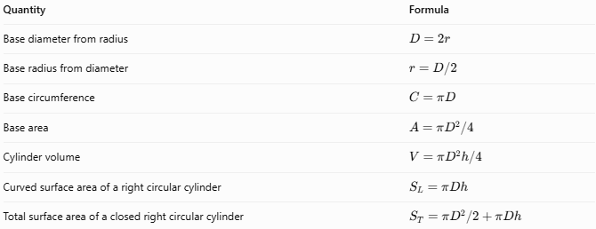
Quantity | Formula
Base diameter from radius | $$D=2r$$
Base radius from diameter | $$r=D/2$$
Base circumference | $$C=πD$$
Base area | $$A=πD^{2}/4$$
Cylinder volume | $$V=πD^{2}h/4$$
Curved surface area of a right circular cylinder | $$S_{L}=πDh$$
Total surface area of a closed right circular cylinder | $$S_{T}=πD^{2}/2+πDh$$
Here, $D$ is the base diameter, $r$ is the base radius, and $h$ is the perpendicular height.

Worked Examples
# Source: AI Source: Provided by: [Data Path: Persons Table -> ID Column: 1, Name_En Column: Motasem Essam] -> From: [ChatGPT] on [7/25/2026]
Example 1: Finding the base diameter
Given: Base radius $r=7\text{ cm}$.
Solution:
$$D=2r=2\left(7\right)$$
Answer: $\boxed{D=14\text{ cm}}$
Example 2: Finding the base radius
Given: Base diameter $D=18\text{ mm}$.
Solution:
$$r=\frac{D}{2}=\frac{18}{2}$$
Answer: $\boxed{r=9\text{ mm}}$
Example 3: Finding the base area
Given: Base diameter $D=10\text{ cm}$.
Solution:
$$A=\frac{πD^{2}}{4}=\frac{π{\left(10\right)}^{2}}{4}$$
Answer: $\boxed{A=25π{\text{ cm}}^{2}}$, approximately $78.54{\text{ cm}}^{2}$.
Example 4: Finding the volume of a cylinder
Given: Base diameter $D=8\text{ cm}$, height $h=15\text{ cm}$.
Solution:
$$V=\frac{πD^{2}h}{4}$$
$$V=\frac{π{\left(8\right)}^{2}\left(15\right)}{4}$$
Answer: $\boxed{V=240π{\text{ cm}}^{3}}$, approximately $753.98{\text{ cm}}^{3}$.

Key Characteristics
# Source: AI Source: Provided by: [Data Path: Persons Table -> ID Column: 1, Name_En Column: Motasem Essam] -> From: [ChatGPT] on [7/25/2026]
- The base diameter is a length, not an area.
- It passes through the center of the circular base.
- It is twice the base radius.
- For a cylinder with congruent circular bases, the top and bottom base diameters are equal.
- Increasing the base diameter increases the base area quadratically: $A=πD^{2}/4$.
- In a hollow cylinder, the inner and outer base diameters are different.

Comparison with Related Measurements
# Source: AI Source: Provided by: [Data Path: Persons Table -> ID Column: 1, Name_En Column: Motasem Essam] -> From: [ChatGPT] on [7/25/2026]
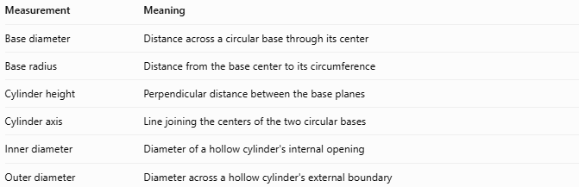
Measurement | Meaning
Base diameter | Distance across a circular base through its center
Base radius | Distance from the base center to its circumference
Cylinder height | Perpendicular distance between the base planes
Cylinder axis | Line joining the centers of the two circular bases
Inner diameter | Diameter of a hollow cylinder's internal opening
Outer diameter | Diameter across a hollow cylinder's external boundary

Applications
# Source: AI Source: Provided by: [Data Path: Persons Table -> ID Column: 1, Name_En Column: Motasem Essam] -> From: [ChatGPT] on [7/25/2026]
- Engineering: specifying cylinder and pipe dimensions.
- Construction: measuring cylindrical columns and supports.
- Manufacturing: determining the dimensions of circular components.
- Geometry: calculating circumference, base area, volume, and surface area.
- Fluid systems: calculating pipe opening area from its internal diameter.

Conclusion
# Source: AI Source: Provided by: [Data Path: Persons Table -> ID Column: 1, Name_En Column: Motasem Essam] -> From: [ChatGPT] on [7/25/2026]
The base diameter is a fundamental measurement of a cylinder's circular base. It equals twice the base radius and is used to calculate the base circumference, base area, volume, and surface area of a cylinder.

